Getting started with Jira

For new users

# Overview

Jira software allows you to track and organize projects in an agile environment. This guide helps you to get started with Jira.

# Key Benefits

* Jira is suitable for different types of users like developers, project managers, technical writers, engineers, and also non-technical professionals.
* Integration is available in Jira, which means the issue and project tracking software can integrate with several third-party software.
* Supports the roadmap requirement.
* Enables users to create any kind of issue.
* Tracking issues and ownership of issues is effortless.
* Highly customisable.

# Prerequisites

* Downloaded and installed Jira software on your device.

# Setting up

After installing Jira software, you must sign up and set it up according to your project needs.

## Signing in

Sign in with your email id and provide a site name to start working.

## Complete set up

Select a type of project and create one under it. After creating projects, you can add issues to it.

# Exploring the Jira User Interface

This section helps you get familiar with the Jira user interface. Refer figure 1 for the features you can see on the Jira homepage after you log in.

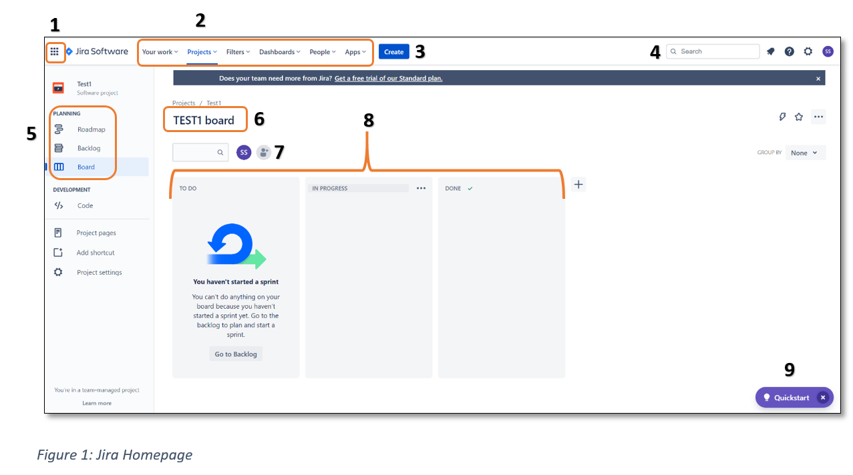

| **NUMBER** | **NAME** | **WHEN TO USE** |
| --- | --- | --- |
| **1** | Navigation menu | To switch to other Jira environments |
| **2** | Quick access  Your work  Projects  Filters  Dashboards  People  Apps | To access any of the functions |
| **3** | Create | To create an issue/ticket |
| **4** | Search | To find an issue |
| **5** | Planning | To plan a project from its inception |
| **6** | Name of project | To view the project name |
| **7** | Add members | To add members to your project |
| **8** | Status of issues | To view the status of tickets in the project |
| **9** | Quickstart | To learn Jira and start using it |

## Navigation menu

After clicking on the Navigation menu, it expands as shown in Figure 2.

* You can choose from various Jira environments under **Switch to** section.
* You can view other integrated apps under the Discoversection.
* You can explore further under the Moresection.

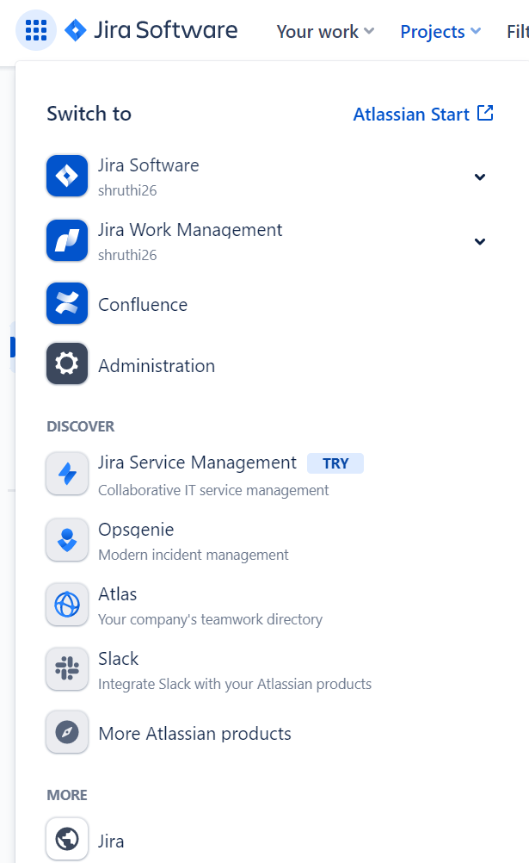

*Figure 2: Jira Navigation menu*

For more information on how to use it, refer to the Navigation menu in the User Guide.

## Quick access

You can find many functions under this quick access ribbon. Each function has several options under it.

### Your work

### Projects

* You can view projects you are part of in this section. It is easy to switch between projects from here.
* You can also add new projects using the Create **project.**

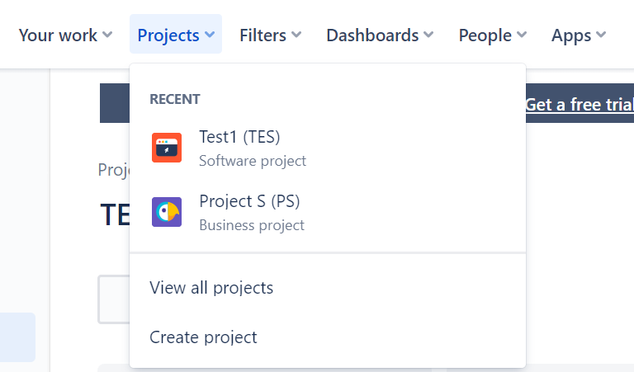

### Filters

### Dashboards

### People

### Apps

## Create

## Search

## Planning

## Name of project

## Add members

## Status of issues

## Quickstart

# Using Jira

## Example 1: How to move issues from one stage to another?

An issue progresses in this fashion To Do 🡪 In Progress 🡪 Done

There are 2 ways to move issues from one stage to another.

**Approach 1: Change status inside the issue detailed view**

1. Open the issue.
2. Click on issue status drop down. You can find it towards the right pane.

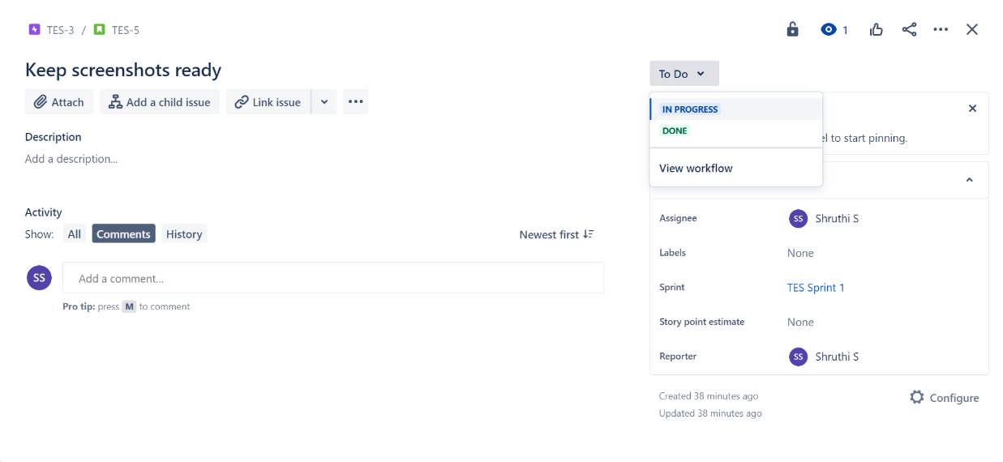

1. Select any other status as applicable.

**Approach 2: Change status in Kanban board view**

1. Open Kanban board to view your sprint with issues in it.
2. Drag an issue from one column and drop it to the required column.

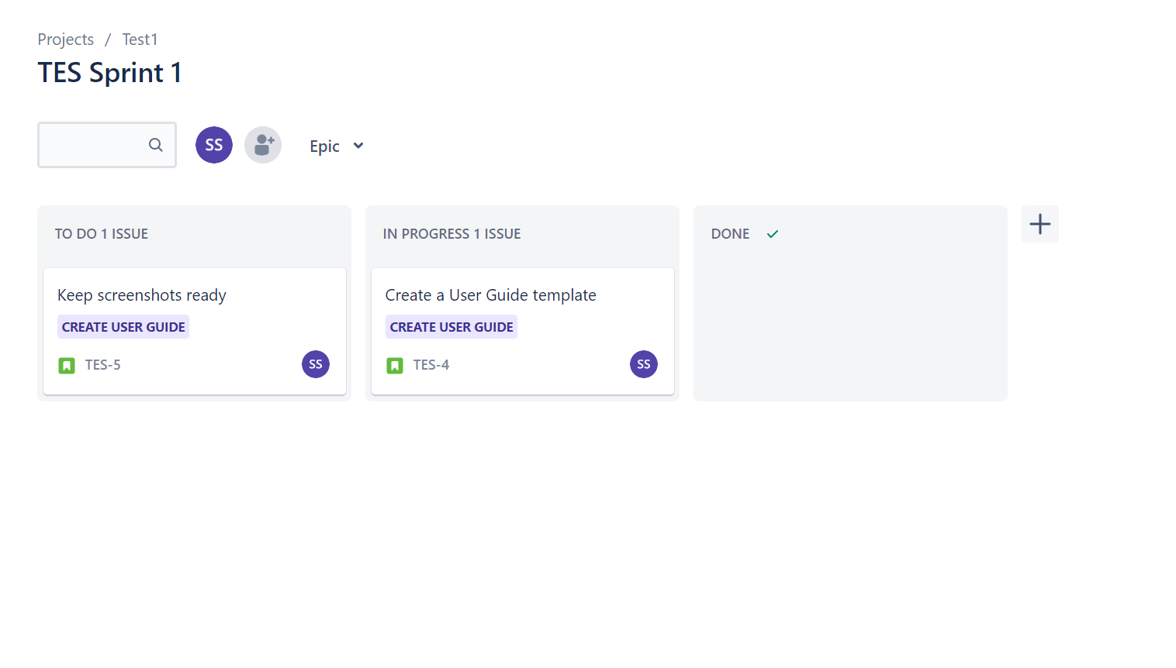

## Example 2:

# FAQs